Budget Rent A Car 
of British Columbia

Global Information System

Reservations Business Design

Version 2.00

Note: The information contained in this document is confidential and may not be disclosed to any parties outside of Budget Rent a Car of British Columbia without written consent by one of its officers.
Copyright (C) 2000 Budget Rent a Car of British Columbia
Table of Contents
1. Functional Area Business Design 1
1.1. Reservations 1
1.1.1. Process Description 1
1.1.1.1. Create/Update Reservations 1
1.1.1.2. Billing 6
1.1.1.3. No Show Reservations 6
1.1.1.4. Outstanding Issues and Questions for Business Design Phase 6
1.1.1.5. Outstanding Retrofits from Subsequent Business Design 8
1.1.2. Screens 9
1.1.2.1. Reservation Entry and Update 9
1.1.2.1.1. Availability Tab 19
1.1.2.1.2. Rate Tab 25
1.1.2.1.3. Rate Tab – Organization/Referral Sub-Tab 26
1.1.2.1.4. Rate Tab – Base Rate Sub-Tab 29
1.1.2.1.4. Rate Tab – Base Rate Sub-Tab 29
1.1.2.1.5. Rate Tab – Extras and Discounts Sub-Tab 36
1.1.2.1.6. Customer and Payment Tab 40
1.1.2.1.7. Comments Tab 50
1.1.2.2. Rate Selection 52
1.1.2.3. Reservation Search 59
1.1.2.4. Deposit/Refund Record 63
1.1.2.5. Reservation History 68
1.1.2.6. Truck Inventory Maintenance 71
1.1.3. Reports 75
1.1.3.1. “No Show” Reservations by Date Range 75
1.1.3.2. Number of Reservations 75
1.1.3.3. Potential No Shows 75
1.1.3.4. Upcoming Direct Bill Reservations with Insufficient Credit 75
1.1.4. Background Processes 75
1.1.4.1. Bill for Maestro No Show Reservations 75
1.1.5. Functions 76
1.1.5.1. Accounting Interface Entries for Reservations 76
1.1.6. Test Scenario List 82
1.1.7. Controls & Audit Trail 85
1.1.8. Security Requirements 85
1.1.9. Business Transaction Volumes 86
1.1.10. Tables without Maintenance Screens 86
1.1.11. Lookup Table Entries 86
1.1.12. Data Model 87
2. Revision History 88
2.1. Version 2.00 88

Functional Area Business Design

Reservations

Process Description
There are four areas that fall under reservations: creating and updating reservations, billing locations for reservations made through the Vancouver Reservation Centre, tracking and issuing incentives for agents at the Reservation Centre, and reservation reporting. Incentives are not included in Phase 1.0 of GIS and billing in Phase 1.0 of GIS is limited to a report listing the reservations made for the locations by the Vancouver Reservation Centre.

Create/Update Reservations
Reservations for the Lower Mainland Budget locations will come from four different sources:
- Vancouver Budget Reservation and Information Centre
Reservation agents will create and update reservations on the new system for customers that phone the Vancouver Budget Reservation and Information Centre and want to make or change a reservation for a future car or truck rental. New reservations will only be taken for rentals in the Lower Mainland area. Customers who wish to make reservations for other Budget locations will be requested to phone Budget’s 1-800 number for out-of-town reservations. Changes to reservations for Lower Mainland rentals, including cancellations and reinstatements, will be accepted for all reservations, regardless of their source. Maestro reservations are an exception in that allowed changes are restricted.
- Individual Lower Mainland Locations, Abbottsford, Chilliwack, and Whistler
Counter reps and administration will create and update reservations on the new system for customers that contact the location and want to make or change a reservation for a future car or truck rental. Each individual location will only be able to create and update reservations for that location. The counter reps and administration will also have the option of pre-writing a contract for a new or updated reservation. This will be used when the reservation is being made in person and the renter wants to sign the rental agreement prior to the start of the rental. This will typically be done when the renter and the driver are not the same person and the renter does not want to come back to the location at the start of the rental period.
- Maestro
This interface function will accept reservations for Budget BC from Maestro and add them to the new system. The information received for a reservation will be similar to the information that will be entered by the reservation agents and counter reps. Maestro reservations have a different reservation number format than reservations entered through Budget BC. This function will also accept changes made through Maestro.
- Internet
As it does currently, a company called WSI will receive reservations entered via the Internet and fax them on a daily basis to Budget BC. The faxed reservations will then be entered on the new system by Budget. The Internet reservation entry facility that customers use to enter reservations assigns a confirmation number and this confirmation number, including the “I” with which all the confirmation numbers are prefixed, will be used as the reservation number when entering the reservation. The “I” will be included to ensure that the numbers are unique.
Future phases may include direct entry of reservations through the internet.
The reservation agents and counter reps will be able to perform any of the following functions:
- Create a new reservation
- Change/Cancel/Reinstate an existing reservation
- Search for an existing reservation
- Copy a reservation
It is critical that all of these functions be easy and quick to use.
Reservation Details
- Create a New Reservation
The information for a new reservation will be entered in the following sections:
  - Vehicle Information
The first step in the reservation process will be to determine where and when the vehicle will be rented and the type of vehicle needed. If this does not match the customer’s requirements, no reservation will be made and no further information will need to be entered.
At this time, if the customer has a BCN, it will be entered. This will populate several fields with predetermined values and will make them non- updateable. These fields include vehicle class, optional extras, sales accessories, customer information, and payment information. If any of these fields require changes, then the BCN must be removed.
Once the vehicle information is entered, the system will show the availability of the requested vehicle class for the specified rental period, first for the requested location and then for other Lower Mainland locations. For trucks, if the vehicle class is available, once the reservation is complete the availability will be reduced for the duration of the requested rental period.
- For truck rentals, the system will show numeric availability for standard truck rental periods. These will be calculated based on current reservations and contracts.
- For car rentals, the system will only show whether reservations for the Vehicle Type requested are being accepted for the Pick Up Location and Pick Up Date specified. Tracking availability for cars is not in scope for the new system.
  - Rate Information
The second step in the reservation process will be to determine the cost of the rental. If this does not match the customer’s requirements, no reservation will be made and no further information will need to be entered.
    - At this time if the customer is a corporate customer or has been referred, the appropriate information and BCD# will be entered in order to access the appropriate rate.
    - A rate will automatically be displayed to the agent. If this rate is not suitable the agent may browse a limited list of rates and select another rate. The agent may also type in a rate name and level to select the rate. The displayed information will include the rate inclusions, restrictions, dollar amounts, and a total cost for the base rate only.
    - Membership discounts may also be recorded. If the customer does not have or is unsatisfied with the membership discount a discretionary flex discount may be applied instead.
    - If the customer requires any Optional Extras (including coverage) or Sales Accessories this can be recorded and an estimated cost for the rental displayed. This is only an estimated cost and is not guaranteed. Availability is not tracked.
  - Customer Information
If vehicle availability and rate match the customer’s requirements, the third step in the reservation process will be to collect the customer information.
The new system will match the customer information against stored customer information including ‘Do Not Rent’ flags.
  - Payment Information. The fourth step in the reservation process will be to record the payment method the customer plans to use for the rental. This is done so that the customer will know in advance whether their intended payment method is acceptable to Budget and any conditions that Budget will impose on that payment method (e.g., the cash rental qualification policy).
The current valid payment methods are credit card, direct billing, and cash.
    - Rental Credit Card Type. If the Rental Payment Method is credit card then a credit card type must be entered.
    - Cash Rental: If the customer does not have a credit card or direct bill company to secure the rental, then Cash will be selected and the system will prompt the agent to notify the customer of Budget’s cash rental policy which is described in the Rental Policies and Procedures Manual, Chapter II. The details of this policy should be available on the system so that the agent does not have to refer to a hard copy.
    - Direct Billing Company Name (mandatory if Rental Payment Method is Direct Billing). The system will verify that a Direct Billing account has been established for the company and will check to see if the expected pre-authorization amount for the rental exceeds the company’s available credit. If it does, the system will issue a warning so that the agent can notify the customer that their company’s credit limit will not currently cover the rental.
  - Deposit Information. Deposit requirements, including amount and minimum cancellation notice will be specified for vehicle classes. If a reservation is cancelled with less than the minimum cancellation notice, the deposit amount will not be refunded. For deposits on car rentals, this will be subject to management review, at least initially. When a deposit is taken for a rental, the minimum cancellation notice will appear on the printed confirmation. Deposits may be waived by the agent.
  - Comments. The length of remark that can be entered will be approximately 2000 characters. A list of predefined standard remarks will be available so the agent can select one or more to be included in the remarks, in addition to adding any comments of their own.
  - Marketing Source. Upon completion of a reservation, the reservation agent will be prompted to enter the marketing source where the customer learned about Budget or about a specific rate or promotion (radio, TV, magazine, word of mouth, etc.).
Once the customer confirms a new reservation, the reservation will be completed. This will save the reservation on the system and assign a reservation number, which is given to the customer. The ID of the agent who made the reservation and the current date and time will also be saved. At this point, truck availability will be reduced. Optionally, the customer may request a faxed confirmation, in which case a fax number or e-mail address is required and a confirmation will be automatically faxed to the customer. E-mail confirmation is out of scope for the first phase of the new system.
If the customer decides not to make a reservation at any point in the reservation process, the reservation agent will be able to Cancel without completing a reservation. When the agent Cancels the reservation function (before or after completion), they will be asked to confirm that they do not want to keep the reservation. At this point, the agent will also be asked to select a reason as to why the customer did not complete or cancelled the reservation.
- Change an Existing Reservation
For existing reservations, this function allows changes to be made to any details of the reservation (except those restricted by BCN use and those restricted when the reservation source is Maestro). All the information that the system makes available at the time of the initial reservation (vehicle availability, rates, etc.) is also available when changes are made to the reservation. This function will not be available once the contract has been opened.
The function allows cancellation of reservations and, when required, subsequent reinstatement. A reinstated reservation will look like the respective reservation at the time it was cancelled and will have to meet the same requirements as new reservation. For example, the rate must still be valid for the rental period and a vehicle must still be available.
When a reservation with a deposit is cancelled with more than the minimum cancellation notice, the cancellation will automatically trigger a refund of the deposit. If the deposit was made with a credit card, the deposit transaction will automatically be reversed; if it was made with cash, the csr will enter whether the refund is to be a direct refund or a mail refund.. For mail refunds, the new system will require the entry of an address for the customer before the refund can be saved. Refunds will be recorded as from the location who processed the cancellation.
When a reservation with a deposit is cancelled with less than the minimum cancellation notice, the deposit will not be refunded. A supervisor override will be provided for this function.
When a cancelled reservation with a deposit is reinstated, the system will validate that another deposit has been collected
- Search for an Existing Reservation
The agent will be able to search for an existing reservation using various information. From the search screen the agent may select a reservation to update, cancel, or reinstate.
- Copy a Reservation
When a new reservation is created, the agent will have the option of cloning it from an existing reservation or contract instead of entering all the information listed above. All the information listed above will be copied, and must be confirmed with the customer and changed (if required) before the reservation is completed and a reservation number is assigned. This facility will be limited to the reservation completed by that agent immediately prior to creating the new reservation. The fact that the reservation was copied is recorded so that reservations can be checked for no shows and fictitious names.

Billing
Lower Mainland operating companies will be billed for reservations made through the Vancouver Reservation and Information Centre. The system will provide a report to facilitate the billing process.

No Show Reservations
No show reservations should be held for a set number of hours after the pick up calendar day. Reservations where the hold period has expired will no longer be included in statistics on projected rental demand and the customer will no longer be guaranteed a vehicle. The new system will flag no show reservations when a contract is opened for them so that the CSR is aware that Budget’s guarantee of a vehicle no longer holds for that reservation. See the No Show Batch Business Design for more details.
Maestro Reservations Requiring a Deposit.
Instead of collecting a deposit at the time the reservation is made, Maestro provides a no show guarantee. If Budget holds the reservation for a set number of hours after the pick up calendar day, Budget will charge the customer the reservation deposit amount. See the No Show Batch Business Design for more details.

Outstanding Issues and Questions for Business Design Phase
Vehicle Class Availability at a Location for Cars
Currently, car availability at locations is determined by a set of from and to dates for each car vehicle class (on the Location Maintenance Screen – General Tab). There is no distinction between whether a vehicle class is not rented at all at a location, or whether the reservations have been blacked out for a period of time. Does this matter? Does the reservation agent need to know this, or is it sufficient for them to know that they can’t make a reservation for that vehicle class and location for a specified pick up date.
Resolution: The design remains as is in that for cars there is no distinction between the black out of a vehicle class and not carrying a vehicle class.
Vehicle Class Availability at a Location for Trucks
Truck availability is tracked by entering truck inventory for each truck vehicle class and location and by updating truck availability whenever a truck is reserved, checked out, or checked in. Calculating truck availability should be resolved soon as possible.
Is it acceptable to only update truck availability when the reservation is completed and when an existing reservation is cancelled or saved, rather than when a truck vehicle class is selected?
- Changing Truck Availability whenever vehicle class, pick up location, pick up time, drop off location or drop off time are changed in a reservation:
  - Changing truck availability on the fly whenever the res agent alters any of vehicle class, pick up location, pick up time, drop off location or drop off time will result in a lot of extra development work. It will be necessary to take action when any one of these fields is updated and to save the values before the change. Changing availability only when a new reservation is completed, or when an existing reservation is cancelled or saved will be much simpler.
  - If two res agents were making a reservation for the same truck class at the same time and there was only one available for the pickup location and time, the second agent would see there was no truck available. If the first agent did not complete their reservation the truck would not be rented by either agent for that pick up location and time.
  - If someone reduced the truck inventory for a location at the same time that an agent was taking a reservation for the last available truck the agent would still be told that the requested vehicle class was no longer available for the requested pick up location and time when they completed the reservation. The agent would then have to return to the availability tab and check the availability for other locations and times.
- Changing Truck Availability only when a new reservation is completed, or when an existing reservation is cancelled or saved:
  - If two res agents were making a reservation for the same truck class at the same time and there was only one available for the pickup location and time, the first agent to complete the reservation would be the one that got the truck. The second agent to complete the reservation would be told that the requested vehicle class was no longer available for the requested pick up location and time. The second agent would then have to return to the availability tab and check the availability for other locations and times.
  - If someone reduced the truck inventory for a location at the same time that an agent was taking a reservation for the last available truck the agent would still be told that the requested vehicle class was no longer available for the requested pick up location and time when they completed the reservation. The agent would then have to return to the availability tab and check the availability for other locations and times.
How common is it for two res agents to be taking a reservation for the same truck vehicle class, pick up location and pick up time at exactly the same time?
Resolved: 98/07/20 – Truck availability will be updated when a new reservation is completed and when an existing reservation is cancelled or saved. Truck availability will also be updated when a contract is opened, checked out and checked in.
Accounting Interface
A description of the exact processing required for the accounting interface will be added after the completion of the Accounting Interface business design.
Credit Card Interface
A description of the exact processing required for credit cards and the credit card interface will be added after the completion of the Credit Card Interface business design.

Outstanding Retrofits from Subsequent Business Design
Foreign Vehicle Models
The Vehicle Model table is now used to store foreign vehicle models for foreign vehicles. When displaying the models available on the Availability tab, models with the Foreign Model Only flag on should be excluded.
Completed.

Screens

Reservation Entry and Update
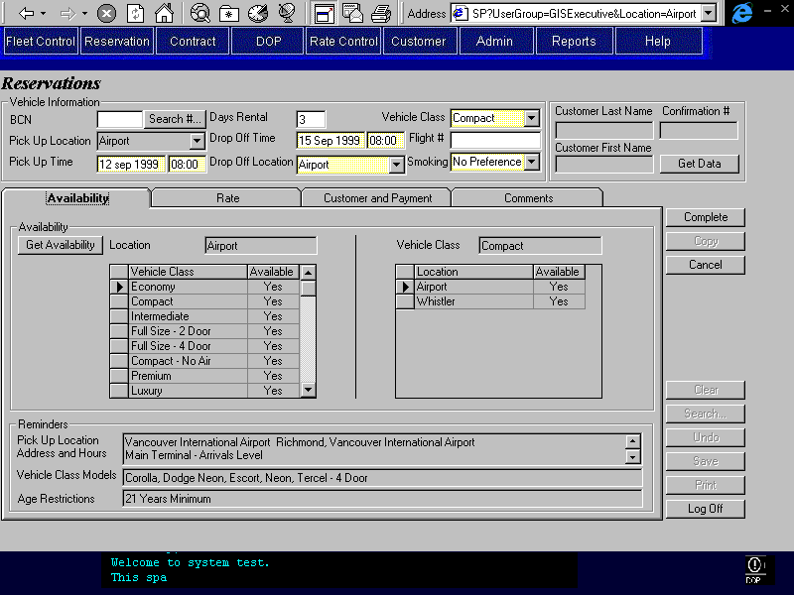
Purpose
The Reservation Entry and Update screen allows for the creation and update of reservations for vehicle rentals. This includes the addition of any sales accessories or optional extras that may be requested by the customer.
This screen may also be used to view reservations that:
- have been previously cancelled,
- have been used to open contracts,
- have been set to no show.
The screen is organized into five areas: the base screen and four tabs. The base screen displays vehicle information, the customer name and confirmation number. The tabs contain the remaining required reservation information and are categorized as follows:
Availability: Where car and truck availability are displayed along with various reminders for the Reservations Agent.
Rate: Where the selected rate and its details are displayed. There are three sub tabs on the Rate tab:
- Organization/Referral: Where organization information or referral information may be entered if applicable.
- Base Rate: Where the selected base rate information is displayed including its inclusions and restrictions. An estimate of the rental cost for the base rate is also shown.
- Extras and Discounts: Where optional extras, sale accessories and discounts may be added or applied to the base rate.
Customer and Payment: Where the customer, payment, and deposit information is entered.
Comments: Where comments may be selected and entered by the reservations agent.
Time is very important for reservations; therefore the screen is designed to reflect the process of a reservation. A reservations agent will navigate first though the base screen (top portion) and then through the tabs in the order that they are displayed.
The screen shown above is what the reservations agent will view upon opening the reservations screen. The purpose of this opening view is to allow the agent to record important initial information that will determine whether a reservation continues. If the reservation continues this information will affect subsequent displayed data and decisions.
The upper portion of the screen (above the tabs) is visible from all tabs. It includes the customer BCN (if applicable), the vehicle information, customer name (display only), and confirmation # (automatically assigned). Complete, Copy, and Cancel buttons are available on the far right.
When a BCN is entered, it will automatically populate several fields, which will then be non-updateable. If any of these defaulted fields require update, the BCN must be removed. Removing the BCN will leave the defaulted information in place but will allow it to be updated. A search button is provided beside the BCN field to allow the reservations agent to search for a BCN if a customer cannot recall it.
Navigation
Search #: Invokes the search customer screen so that a BCN may be selected and returned to the reservation entry and update screen.
Search…: Invokes the reservation search screen so that a reservation may be searched on and returned to this screen. If the status of the reservation is ‘Active’ and the current location is the pick up location or Reznet then the reservation may be updated (maestro reservation update is limited to the rate name and level). If the reservation status is ‘Opened’ or ‘No Show’ then the reservation may only be viewed. When a ‘Cancelled’ reservation is selected the user will be asked if they wish to reinstate the reservation. If ‘Yes’ is selected, then the updateability rules are the same as those for an ‘Active’ reservation. If ‘No’ is selected then the reservation is view only.
Functions
Get Data: Retrieves availability, rates, and BCN customer information.
Complete: Checks that all required information has been entered and then saves the reservation and generates a confirmation number. Prompts agent to select the marketing source from which the customer heard about Budget. Returns the screen to the Rate tab, Base Rate sub-tab.
Copy: Copies the current reservation and displays the copy. The copy will require deposit authorization (if required) and completion (pressing the complete button) before a confirmation number is assigned. The copied reservation is flagged as copied. The copy functionality is only available immediately following the completion of a reservation and the reservation that has just been completed, is the only reservation that may be copied.
Cancel: For new reservations:
- If a credit card deposit has been collected then the cancel button is disabled. (In this case, the CSR must complete the reservation before they can cancel the reservation so that the deposit can be refunded.)
- Prompts agent to select a reason as to why reservation was not completed
- Ends process and does not save reservation
- Saves cancellation reason, date, and user ID in Turndown Reservation
- Clears fields and returns screen to Availability tab.
For previously completed reservations:
- Prompts user to select a reason as to why reservation was cancelled. If a deposit was collected for the reservation and the cancellation is being done after the minimum period required for cancellation notice for that vehicle class, the user will also be able to override the forfeit of the deposit. This will require manager or supervisor access.
- Changes reservation status to cancelled
- If a deposit was collected for the reservation:
- If the cancellation was done prior to the minimum period required for cancellation notice for that vehicle class or if the refund forfeit has been overridden:
- If the Deposit Payment Method was cash, prompts the user to select the type of cash refund (direct or mail).
- If mail refund is selected, advises user to confirm the customer address and allows the user to enter or update the customers address. The address information will be saved to the reservation remarks.
- If direct refund is selected, prints a cash refund receipt and advises user to obtain the customers signature.
- If the Deposit Payment Method was Credit Card, invokes the function for a credit card refund for the deposit amount. Successful processing of the refund will invoke accounting transactions and return an authorization number to the Reservation Entry/Update screen. If the automatic credit card refund process is unsuccessful opens the manual credit transaction screen.
- Saves updated reservation
- Clears fields and returns screen to Availability tab
Clear: This will be available from all tabs but will return the agent to the Availability tab so that a new reservation may be entered. If any changes have been made to a new reservation, then it must be completed or cancelled before it can be cleared. If any changes have been made to an existing (completed) reservation, then it must be saved, cancelled, or undone before it can be cleared
Save: A new reservation must be completed before the save button can be enabled. Save will update the reservation, and will create a reservation change history record if any of the following fields were changed:
- Pick Up Location
- Pick Up Time
- Drop Off Location
- Drop Off Time
- Vehicle Class
- Selected Rate
- Customer Name
- Reservation Status

Controls
Field | Source | Req* | Validation | Comments
Above Tabs
BCN | Reservation, Program Number | N | Value controlled by Customer table. | See Technical Notes for more details.
Pick Up Location | Reservation, Pick Up Location ID | Y | Value controlled by Location table.  If the reservation is being taken at a non-reznet location, that location is the only valid pick up location. | Location name displayed.  Rental Location = Yes, For Reznet: Reznet Location = Yes.
Pick Up Time (date) | Reservation, Pick Up On | Y | Date
Pick Up Time (time) | Reservation, Pick Up On | Y | Time (24 hour) | Check to ensure that the pick up time is not outside the business hours of the selected pick up location.
Days Rental |  | S | Difference between Pick Up Time and Drop Off Time.  Numeric for cars. Numeric or AM, PM, OV, A/P, P/O, O/A for trucks. | Either Drop Off Time or Days Rental is entered. One can be automatically calculated from the other.
Drop Off Time (date) | Reservation, Drop Off On | S | Date | Either Drop Off Time or Days Rental is entered. One can be automatically calculated from the other.
Drop Off Time (time) | Reservation, Drop Off On | S | Time (24 hour) | Time will default to the value of the Pick Up Time (time).
Drop off Location | Reservation, Drop Off Location ID | Y | Value controlled by Pick Up/Drop Off Location table. | Location name is displayed.  This will default to the same location as the pick up location, but may be changed.
Vehicle Class | Reservation, Vehicle Class Code | Y | Value controlled by Location Vehicle Class table (for the specified pick up location). | Vehicle Class Name is displayed.
Smoking | Reservation, Smoking/Non-Smoking | Y | No Preference, Smoking, Non-Smoking | Default: No Preference
Flight # | Reservation, Flight Number | N | Free form text
Customer Last Name | Reservation, Last Name | D |  | The same value as is entered in the Customer/Payment tab.
Customer First Name | Reservation, First Name | D |  | The same value as is entered in the Customer/Payment tab.
Confirmation # | Reservation, Confirmation Number or Foreign Confirmation Number | Y | Not updateable after creation. | Automatically populated upon completing reservation if not already entered.  See technical notes.
Technical Notes
Pick Up/Drop Off Times:
A check is required to ensure that a pick up time cannot be specified outside the specified location’s hours of service. For the specified date and location, the pick up time will be verified against the following table fields: Hours of Service, Day of Week; Hours of Service, Opens At; and Hours of Service, Closes At. If an invalid pick up time is selected an alert will be displayed and the user will be forced to correct the time before continuing. The check should occur as soon as it technically feasible to minimize disruption to the reservation process.
Confirmation Number:
The confirmation number may be produced in three ways:
- Reservations made through Reznet or the GIS Locations: Upon completion of the reservation (pressing the complete button), the confirmation number is automatically produced and displayed.
- Maestro reservations will already be assigned a confirmation number. This number will be displayed and is not updateable. Maestro reservations will be automatically loaded through the Maestro Interface.
- Internet reservations will already be assigned a confirmation number prefixed with an ‘I’. The internet reservations are entered into GIS using the Reservation Entry/Update screen.

The Reservation Entry and Update screen must be able to accommodate the first and third situations outlined above. To accomplish this, for new reservations the confirmation # field should be enterable with the restriction that any entered confirmation number must be prefixed with an ‘I’. If no confirmation number is entered, then upon completion (pressing the complete button) a confirmation number will be automatically generated. Once a reservation has been completed the confirmation number cannot be updated. The confirmation # field should remain grey in colour to indicate that it is read only since entering a confirmation number is a special case.
Cancelling a Reservation Prior to Completion:
When a reservation is cancelled before it has been completed, it is not saved as a reservation. A turndown reason, the date, and user ID is stored in the Turndown Reservation table.
Completing a Reservation with a Deposit:
Create a Reservation Deposit Payment Method record Detail record for any deposit collected. Further Processing for cash and credit card payments to be designed as part of Accounting Interface. Processing for authorizing credit card payments to be designed as part of the Credit Card Interface.
Cancelling an Existing Reservation with a Deposit:
Create a Reservation Deposit Detail record for any refund issued. Further Processing for cash and credit card refunds to be designed as part of Accounting Interface.
Saving an Updated Reservation:
When an existing reservation is changed and saved, create a reservation change history record if any of the following fields were changed:
- Pick Up Location
- Pick Up Time
- Drop Off Location
- Drop Off Time
- Vehicle Class
- Selected Rate
- Customer Name (first and last)
- Reservation Status change (reservation cancelled, reinstated, used for a contract, or changed to no show)
Create the record using the latest values from the reservation table (including Last Changed By and Last Changed On).
Populating Reservation Information from Customer Profile with a BCN:
When a BCN number is entered the information associated with the customer profile associated with the BCN should be populated in the screen and made non-updateable. This includes Vehicle Class, Customer Information, Optional Extras (including LDW), Sales Accessories, Member Discount, Credit Card and Payment Information. Deposit information and BCD Rate Organization information should also be populated but should remain updateable. The Customer’s Fax number should also remain updateable (update in reservation only, not customer profile).

When the BCN number is removed the previously populated and locked fields should become unlocked but retain their information.

Once a reservation is completed or saved without a BCN number, a BCN number cannot be added.

If Customer.LDW is Yes
- Find the Optional Extra with Type LDW that has the lowest deductible for Customer.Vehicle Class Code and add it to the list of reserved Optional Extras on the Extras and Discounts Sub-Tab of the Rate Tab.
If Customer PAI is Yes
- Find the Optional Extra with Type PAI add it to the list of reserved Optional Extras on the Extras and Discounts Sub-Tab of the Rate Tab.
If Customer PEC is Yes
- Find the Optional Extra with Type PEC and add it to the list of reserved Optional Extras on the Extras and Discounts Sub-Tab of the Rate Tab.
Maestro Reservations:
See the Maestro Interface Business Design document for a description of the how the reservations screen is to operate for Maestro reservations.
Updateability of Retrieved Reservations:
For reservations with a status of ‘Active’, if the current location is the pick up location or Reznet then the reservation should be updateable. Otherwise the reservation should be view only.
For reservations with a status of ‘Cancelled’, if the current location is the pick up location or Reznet then the user should have the option to reinstate the reservation. If the user selects to reinstate the reservation then the reservation should be updateble, otherwise the reservation should be view only.
For reservations with a status of ‘Opened’ or ‘No Show’, the reservation should be view only regardless of the current location.
Note that for Maestro reservations the rules stated above are true. However, the only fields updateable on a Maestro reservation are the rate name and level fields (provided that the user has sufficient security to update them).
Updating Truck Availability:
Reservations for vehicle classes with a type of ‘Truck’, will update the Truck Availability as described below. The Truck Inventory table, AM Availability, PM Availability and OV Availability fields will be affected. The availability is update for the selected pick up location and truck vehicle class.
Complete: Subtract 1 from all time periods affected by the reservation. A time period is considered affected by the reservation if the reservation duration extends into the time period.
Save: Add 1 to all time periods affected by the reservation prior to the save and subtract 1 from all time periods affected following the save.
Cancel: For cancellation where the reservation record has been or is being saved, add 1 for all time periods affected by the reservation prior to the update (cancellation). Note that cancellations of reservations result in only a turndown record do not affect availability.

Availability Tab
Car Availability:
Truck Availability:
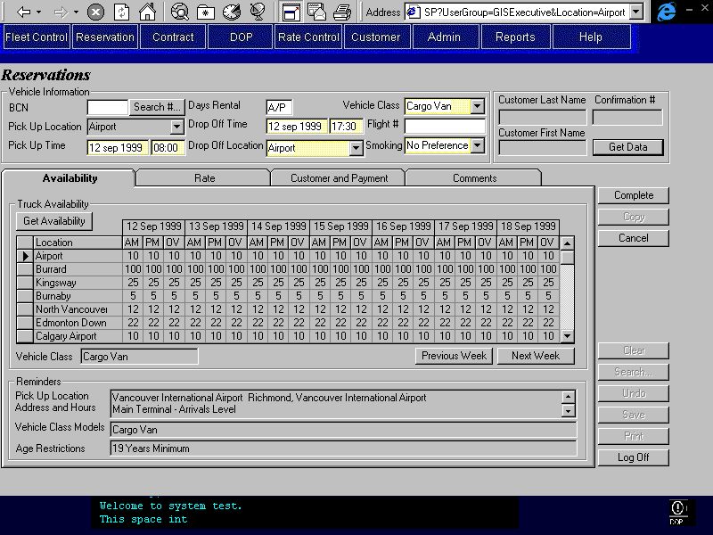
Purpose
There are two basic categories of availability: Car and Truck. The information displayed is dependent upon the entries in the vehicle information section (top of screen).
Car availability will display whether or not reservations are being accepted for a vehicle class. The availability information is organized by location and by vehicle class. Availability by location will display all car classes available at the selected pick up location. Availability by vehicle class will display all locations within a defined location hub (of which the pick up location is a member). The hub is determined by proximity and is defined elsewhere in the system.
Truck availability will display how many trucks are available for each time block at each location. The locations that carry trucks within the pick up location hub will be displayed first, then the other locations that carry trucks will be displayed. Seven days will be displayed at a time starting with the pick up day. The next week and previous week buttons may be used to view other time periods.
An agent cannot make a reservation for a car or truck that is not available (availability = No or 0). A supervisor may override this restriction and reserve a vehicle that is showing no availability.
Directly below the car and truck availability, there are message areas that provide the reservations agent with required information based on the entries made in the vehicle information section.
Navigation
N/A
Functions
Get Availability: Populates the Availability tab with the information relevant to the data entered in the following fields in the vehicle information section: Pick Up Location, Pick Up Time, and Vehicle Class.
Previous Week: Displays the availability for the seven days preceding the days currently shown.
Next Week: Displays the availability for the seven days following the days currently shown.
Controls
Field | Source | Req* | Validation | Comments
Car Availability by Location
Location | Reservation, Pick Up Location ID | D |  | Value same as selected pick up location. Location name displayed.
Vehicle Class | Location Vehicle Class, Vehicle Class Code | D |  | Values determined by selected pick up location. Vehicle Class name displayed.
Available |  | D | Yes, No | Yes if Pick Up Time falls within Valid From/To for any Location Vehicle Class record for the selected Pick Up Location and Vehicle Class, No otherwise.
Car Availability by Vehicle Class
Vehicle Class | Reservation, Vehicle Class Code | D |  | Value same as selected vehicle class. Vehicle Class name displayed.
Location | Location Vehicle Class, Location ID | D |  | Values determined by selected vehicle class. Only display locations that are members of the same hub. Location name displayed.
Available |  | D | Yes, No | Yes if Pick Up Time falls within Valid From/To for any Location Vehicle Class record for the selected Pick Up Location and Vehicle Class, No otherwise.
Truck Availability by Location and Day |  |  |  | See technical notes.
Location | Reservation, Pick Up Location ID; Location Vehicle Class, Location ID | D |  | First row value same as selected pick up location. Location name displayed. See Technical Notes for sort order of remaining locations.
Vehicle Class | Reservation, Vehicle Class Code | D |  | Value same as selected vehicle class. Vehicle Class name displayed.
Day | Truck Inventory, Date | D |  | Display seven days starting with pick up date.
Available – AM | Truck Inventory, AM Availability | D | Numeric (includes 0 and negative) | Value determined by pick up location and pick up time.
Available – PM | Truck Inventory, PM Availability | D | Numeric (includes 0 and negative) | Value determined by pick up location and pick up time.
Available – OV | Truck Inventory, OV Availability | D | Numeric (includes 0 and negative) | Value determined by pick up location and pick up time.
Pick Up Location Address and Hours (address) | Location, Address1 + Address2 + City + Address Description | D |  | Value determined by selected pick up location. Concatenate the values.
Pick Up Location Address and Hours (hours) | Location, Hour of Service Description | D |  | Value determined by selected pick up location.
Vehicle Class Models | Vehicle Model Year, Model Name | D |  | Value determined by selected vehicle class. Do not list foreign models.
Age Restrictions | Vehicle Class, Age Restriction | D |  | Value determined by selected vehicle class.
Technical Notes
Sort Order for Locations in Truck Availability:
- the first location displayed will be the current location
- then the remaining locations that carry the vehicle class and are in the same hub, in alphabetical order
- then the remaining locations that carry the vehicle class, sorted by hub, and then alphabetical order

Rate Tab
Purpose
This tab allows the reservation agent to select a suitable rate for the customer and add optional extras and accessories as required.
The tab is organized into three sub-tabs; the order of the sub-tabs reflects the order in which the reservation agent will enter or view information. Detailed descriptions of the sub-tabs are included in the next sections. The three sub-tabs are as follows:
Organization/Referral: Where Organization information or Referral Information may be entered if applicable.
Base Rate: Where the selected base rate information is displayed including its inclusions and restrictions.
Extras and Discounts: Where optional extras, sale accessories and discounts may be added or applied to the base rate.

Rate Tab – Organization/Referral Sub-Tab
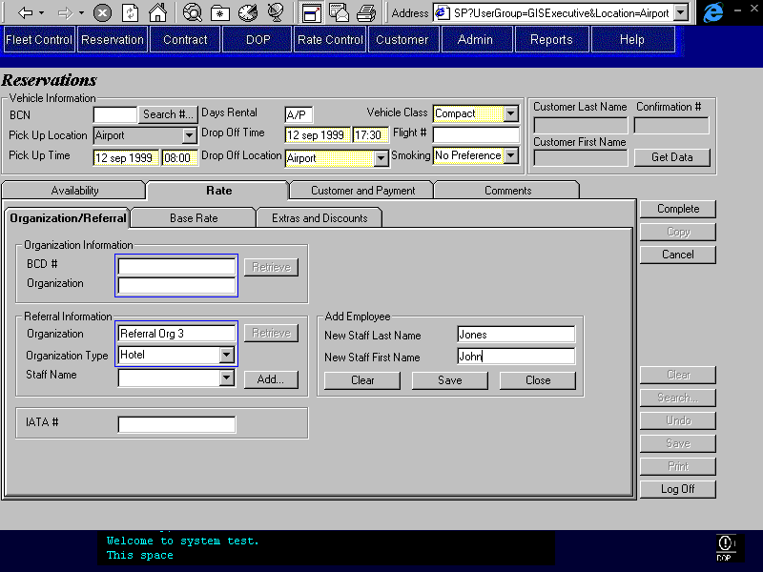
Purpose
The Organization/Referral sub-tab allows the reservation agent to enter relevant organization or referral information so that the appropriate rate may be made available.
After viewing the availability, the reservations agent will go to the rate tab and the first sub-tab (Organization/Referral) will be visible. The agent may then enter organization or referral information if applicable.
Navigation
N/A
Functions
Retrieve (BCD rate organization): Searches for an organization based on BCD number and/or organization name. Display a list containing organization name and address. Selected organization name and BCD number will be returned.
Retrieve (referral): Searches for a referral organization based on the referral organization type and name. Display a list containing organization name and address. Selected organization name will be returned. Provide option to use rate associated with the referral company.
Add New Staff: Brings up a pop up dialogue and allows entry of a referral staff name that is not currently on the list of employees for the referring organization. This new staff name should be added to the list of referring employees when the reservation is completed or saved.
Controls
Field | Source | Req* | Validation | Comments
Organization Information
BCD # | Reservation, BCD Rate Organization ID | N |  | Organization BCD Number is entered and displayed. If enter or update number must press retrieve button.
Organization | Reservation, BCD Rate Organization ID | N | Free form text. | Organization name is entered and displayed. If enter or update name must press retrieve button.
Referral Information
Organization Type | Reservation, Referral Organization ID | N | Value controlled by Organization type table. | Organization type displayed. If enter or update type must press retrieve button.
Organization | Reservation, Referral Organization ID | N | Free form text. | Organization name is entered and displayed. If enter or update name must press retrieve button.
Staff Name | Reservation, Referring Employee ID | N | Selection list determined by Referring Employee table for the selected Organization. | Employee name is selected and displayed.
Add Employee Box |  |  |  | This will add an employee record to the Referring Employee table for the selected Organization.
New Staff Last Name | Referring Employee, Last Name | N | For selected Organization.
New Staff First Name | Referring Employee, First Name | N | For selected Organization.
IATA # | Reservation, IATA Number | N | 8 digit code. Check last digit. See technical notes.
Technical Notes
IATA Modulus Check Digit:
The modulus check digit is derived by taking Modulus 7 of the first seven digits. An error should be given if the user enters a number that does not have a valid check digit. The exception is if the check digit is a character, then the verification will not be done.

Rate Tab – Base Rate Sub-Tab
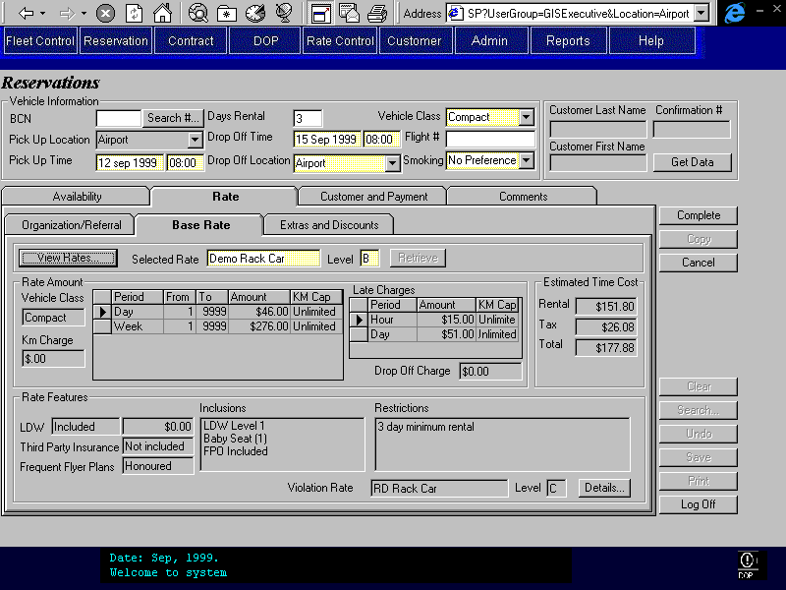
Purpose
The Base Rate sub-tab displays the selected rate information so that the reservations agent may communicate the rate information to the customer.
Upon navigating to the Base Rate tab, a rate will be automatically selected and displayed based on the previously entered information. If the agent wishes to see other available rates, they may select the View Rates button to select another rate from a limited list of rates. The rates displayed for selection are determined by previously entered information in the reservation (pick up location, pick up time, days rental, drop off location, and vehicle class) and settings determined in the Location Maintenance screen. Upon selecting another rate from the list, the new rate information will be displayed in the Base Rate tab. If the agent wishes to see a specific rate, they may enter the rate name and level and then press the retrieve button.
The base rate information displayed is for the selected vehicle class only. All dollar rate information, late charges, km cap and charges, inclusions, and restrictions are displayed. Also displayed are whether or not LDW and third party insurance are included, and whether frequent flyer plans are honoured. If applicable, a violation rate will also be displayed. The agent may select the Details button if they wish to view information about the violation rate.
Estimated time cost is calculated and displayed for the selected rate. This is the estimated cost for the rental based on the selected rate and rental length. The cost of any additional sales accessories or optional extras, which are not included in the rate, are not included in this estimate.
Navigation
View Rates: Invokes the Rate Selection screen and returns the selected rate information to the Reservations Entry/Update screen.
Details: Invokes a screen that will display the rate information for the violation rate. This screen will contain the same information that is displayed in the base rate tab with the exception of the violation rate since violation rates cannot be nested. Upon exiting the user will return to the base rate sub-tab.
Functions
Display Rate: Upon navigating to the base rate tab, a rate will automatically be selected and displayed based on the information previously entered in the reservation. The rate displayed will be the BCD rate or Referral rate if applicable or else the Rack rate.
Retrieve (rate): Retrieves the rate information based on an exact match found for the rate name and level entered. This button is disabled unless the user types in the rate name/level fields. No wild card search is provided.
Controls
Field | Source | Req* | Validation | Comments
Selected Rate | Reservation, Rate Name ID and Rate Assigned Date | Y | Free form text.  Rate name displayed. | Automatically determined or determined by rate selection screen. User may enter name as well but is then forced to press retrieve button. Rate name displayed.
Selected Rate Level | Reservation, Rate Level and Rate Assigned Date | Y | Valid values A to Z. | Automatically determined or determined by rate selection screen. User may enter name as well but is then forced to press retrieve button.
Vehicle Class | Rate Vehicle Class, Vehicle Class Code | D |  | For selected rate and rate assigned date. Value same as selected vehicle class. Vehicle Class name displayed.
Km Charge | Rate Vehicle Class, Per Km Charge | D |  | For rate, rate assigned date and vehicle class.
Period | Rate Time Period, Time Period | D |  | For selected rate, rate assigned date and Type = Regular.
From | Rate Time Period, Time Period Start | D |  | For rate, rate assigned date and time period.
To | Rate Time Period, Time Period End | D |  | For rate, rate assigned date and time period.
Amount | Rate Charge Amount, Amount | D |  | For rate, rate assigned date, time period, and vehicle class.
Km Cap | Rate Time Period, Km Cap | D |  | For rate, rate assigned date and time period.
Late Charge Period | Rate Time Period, Time Period | D |  | For selected rate and rate assigned date.
Late Charge Amount | Rate Charge Amount, Amount | D |  | Type is Late. For selected rate, rate assigned date, time period, and vehicle class.
Late Charge Km Cap | Rate Time Period, Km Cap | D |  | For rate, rate assigned date and time period.
Drop Off Charge | Pick Up/Drop Off Location, Authorized Charge; Rate Drop Off Location, Included in Rate | D |  | For specified pick up and drop off location, selected rate and rate assigned date. If Km Drop Off Charge is Yes for the rate, display ‘Km charge’ instead.. If Rate Drop Off Location, Included in Rate is true, then drop off charge is 0.
LDW (included) | Included Optional Extra, Optional Extra ID; Optional Extra, Type | D |  | ‘included’ if the rate has an Included Optional Extra with Optional Extra, Type = LDW, ‘not included’ otherwise. For selected rate and rate assigned date.
LDW (deductible) | Included Optional Extra, Optional Extra ID; LDW Deductible, LDW Deductible | D |  | Only displays if the rate has an Included Optional Extra with Optional Extra, Type = LDW. The LDW Deductible record used is the one for the selected vehicle class and the Included Optional Extra with Optional Extra, Type = ‘LDW’.
Third Party Insurance | Included Optional Extra, Optional Extra ID; Optional Extra, Type | D |  | ‘included’ if the rate has an Included Optional Extra with Optional Extra, Type = Third Party Insurance, ‘not included’ otherwise. For selected rate and rate assigned date.
Frequent Flyer Plans | Vehicle Rate, Frequent Flyer Plans Honoured | D |  | ‘honoured’ if Yes, otherwise ‘not honoured’. For selected rate and rate assigned date.
Inclusions | Included Optional Extra, Optional Extra ID;  Included Sales Accessory, Sales Accessory ID;  Vehicle Rate, GST Included, PST Included, PVRT Included, Location Fee Included | D |  | List all inclusions in one list (optional extras, sales accessories, and taxes). Only list tax and location fee inclusions if value is yes. For selected rate and rate assigned date.
Restrictions | Rate Restriction, Restriction ID, Time of Day, Number of Days, Number of Hours;  Vehicle Rate, Special Restrictions | D |  | List both Restrictions and Special Restriction in list. For Restrictions, concatenate Rate Restriction fields. For selected rate and rate assigned date.
Violation Rate | Vehicle Rate, Violation Rate ID | D |  | Rate name displayed. For selected rate and rate assigned date.
Level (violation rate level) | Vehicle Rate, Violation Rate Level | D |  | Rate level displayed. For selected rate and rate assigned date.
Estimated Time Cost
Rental |  | D | Currency | Calculated: Base rate - Flex Discount + Location Fee. Expressed in Canadian Dollars. See technical notes.
Tax |  | D | Currency | Calculated: Sum of GST, PST, and PVRT unless they are included in the rate.  Expressed in Canadian Dollars.
Total |  | D | Currency | Calculated: Rental + Tax.  Expressed in Canadian dollars.
Technical Notes
Estimate Time Cost Calculation:
The estimate time cost calculation includes only the base rate amount, the flex discount (if applicable), and the location fees. Optional extras, sales accessories, and membership discounts are not included in the cost calculation.
To calculate the base rate amount the cheapest combination of the defined time periods should be used to total the rental period. For example:
- A rate has a daily time period assigned $40 per day, and a weekly time period assigned $250 per week.
- The rental period is 11 days.
- For the first seven days, the daily rate sum is $280 and the weekly rate sum is $250. Therefore the weekly rate is used for the first seven days.
- For the 8th to 11th day (4 days), the daily rate sum is $160 and the weekly rate sum is $250. Therefore the daily rate is used for the last 4 days.
- The total for the rental period is $250 + $160 = $410
For more details see the Calculate Rental Costs in the Contract Part 1 document. Note that only regular time charges are used for the estimated time cost in reservations.

The flex discount is a percentage that is applied only to the estimate time cost fields. It does not affect the base rate amount fields.
Displaying Inclusions:
When the item being displayed is a flag, display the flag name if the value is Yes and nothing if the value is No.
Displaying Restrictions:
For restrictions that use the parameters Number of Hours or Number of Days, concatenate by displaying the parameter first and then the restriction text.
For restrictions that use the parameter Time of Day, concatenate by displaying the restriction test first and then the parameter.

Rate Tab – Extras and Discounts Sub-Tab
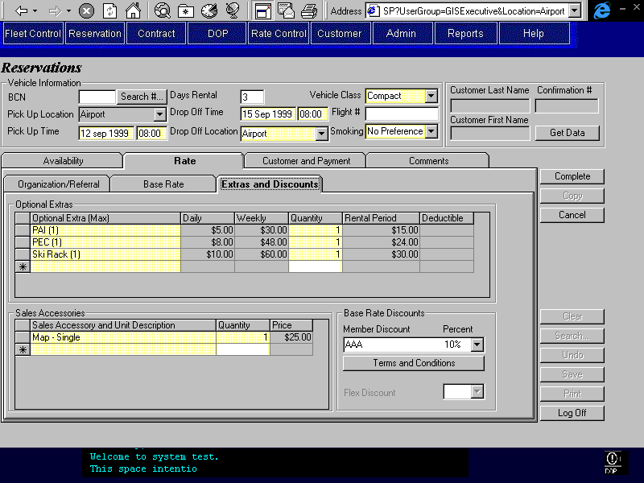
Purpose
The Extras and Discounts sub-tab allows the reservation agent to select optional extras (including LDW) and sales accessories so that they may quote an estimated cost to the customer and so that the request for the sales accessory or optional extra is recorded. Discounts may also be applied here, if required to keep a customer's business.
After viewing the selected base rate the agent will go to the Extras and Discounts tab. If required, optional extras and sales accessories may be selected and a quantity specified. The optional extras available for selection are applicable for the selected vehicle class. Daily, weekly and total rental period cost estimates will be given for each selected optional extra. The sales accessories available for selection are applicable for the selected pick up location. Unit description and price is displayed for each selected sales accessory. LDW may also be selected as an optional extra if it is not already included in the rate. The deductible is displayed in the last column of the optional extra section.
Discounts are also recorded on this sub-tab. The agent may apply a flex discount if they determine it is required to keep the customers business. The flex discount amount is a percentage, which is applied at predetermined increments. This percent is deducted from the estimate time cost on the base rate tab. Membership discounts may be recorded but do not affect the rental cost calculations. Membership discounts are for information purposes to help the agent to determine if a flex discount is required. Only one discount (membership or flex) may be applied.
Note that if a BCN has been entered then the Optional Extras, Sales Accessories, and LDW are defaulted to predetermined values and cannot be updated unless the BCN is removed. Membership discount is also locked.
Navigation
N/A
Functions
Terms and Conditions: Displays the terms and conditions associated with the membership discount selected.
Controls
Field | Source | Req* | Validation | Comments
Optional Extras
Option | Reserved Optional Extra, Optional Extra ID | N | Value controlled by Optional Extra table and Vehicle Class Optional Extra table | Optional Extra name is displayed (with the maximum quantity in brackets).
Daily | Optional Extra Price, Daily Rate | D | Currency | For selected Optional Extra. Rate will not vary with quantity.
Weekly | Optional Extra Price, Weekly Rate | D | Currency | For selected Optional Extra. Rate will not vary with quantity.
Quantity | Reserved Optional Extra, Quantity | Y | Numeric  Must be less than or equal to maximum allowable quantity for the selected option.
Rental Period |  | D | Currency | Calculated based on rental period and quantity. Displays cheapest combination of daily and weekly rates.
Deductible | LDW Deductible, LDW Deductible. | D | Currency | For Selected Optional Extra and Vehicle Class.
Sales Accessories
Accessory | Reserved Sales Accessory, Sales Accessory ID | N | Value controlled by Location Sales Accessory table. | Sales Accessory name and Unit Description displayed.
Quantity | Reserved Sales Accessory, Quantity | Y | Numeric
Price |  | D | Currency | Calculated based on quantity and Location Sales Accessory, Price (if null then use Sales Accessory Price, Price).
Discounts
Member Discount | Reservation, Member Discount ID | N | Value controlled by Member Discount table | Discount (name) displayed.
Percent | Member Discount, Percentage | D |  | For selected member discount. Does not affect estimated time cost.
Flex Discount | Reservation, Flex Discount | N | 10, 15, 20, or 25 percent. | Applied to estimated time cost. Will be disabled if Flex Discount Allowed is No for the rate being used.
Technical Notes
Optional Extras:
Only one optional extra of type LDW may be selected.
Only one optional extra of type PAI may be selected.
Only one optional extra of type PEC may be selected.
Only one optional extra of type Third Party Insurance may be selected.
Only one optional extra of type Cargo Insurance may be selected.
Included optional extras must be considered when determining if an optional extra of a specified type has already been entered. Coverages included in rate will not be checked. This will allow for BCN reservations where the BCN customer profile requests a coverage that is also included in the rate. Contract Open/Check Out will ensure that only one of each type of coverage is included or purchased on the contract.
The available list of optional extras to select from should be filtered so that it does not include any entries found in the Optional Extra Restriction table for the specified vehicle class.

Customer and Payment Tab
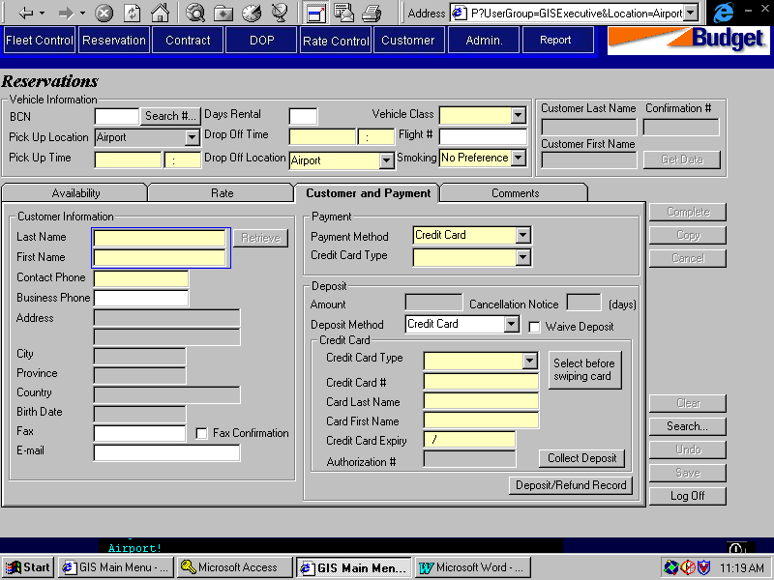

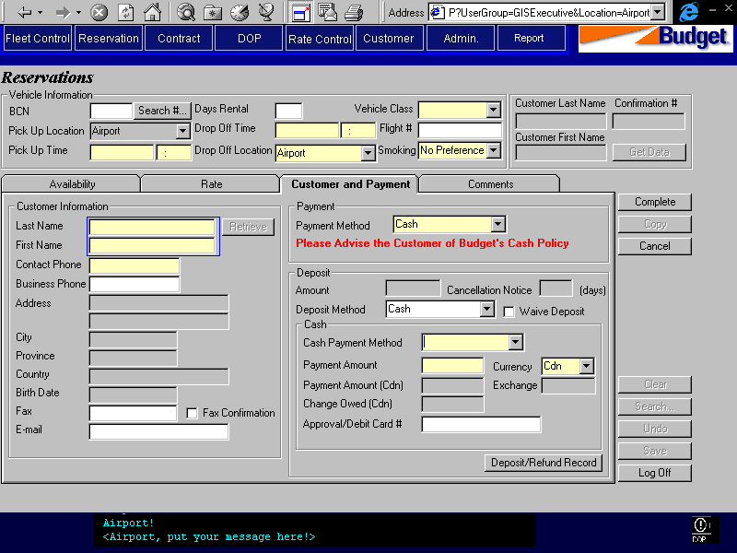
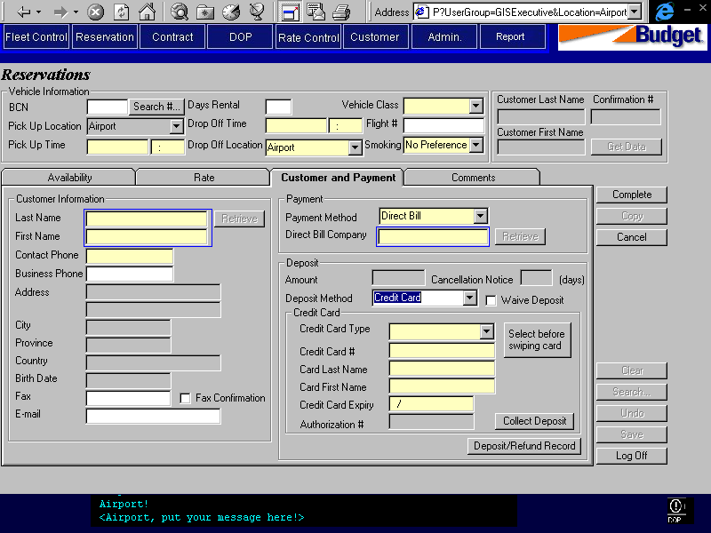
Purpose
The Customer and Payment tab allows the reservation agent to enter relevant customer, payment and deposit information. Checks will be run on customer information to ensure that the customer is not an unwanted customer. The payment and deposit information is used to ensure correct payment methods are used and to authorize a deposit payment if required.
The information on this tab is laid out in the order in which the agent will enter it. Customer information will be collected first, starting with the last and first name only. The agent will then select the Retrieve button. This will search for the customer against a list of known customers. A list with extra identifying information will be presented to the agent so that they may confirm and select the appropriate customer from the list. The list will include last name, first name, address, phone number, birth date, and whether or not the customer is flagged as ‘do not rent’. Upon selecting a customer from the list, the remaining customer information fields will be automatically populated. If no match is found, then the agent will be required to enter the contact phone number and business phone number (optional) of the customer.
If required a confirmation may be faxed to a customer. To record this the Fax number must be entered (if not already populated) and the Fax Confirmation checkbox must be selected.
After obtaining the customer information the agent will then request payment information. Payment method is defaulted to ‘Credit Card’. Credit card type must be selected if Payment method is ‘Credit Card’. If ‘Cash’ is selected for payment method, then a message will be displayed alerting the agent to advise the customer of Budget’s cash policy. If ‘Direct Payment’ is selected for payment method then the direct payment company must be entered. The company name is entered and then the Retrieve button selected. A list of potential matching companies will be displayed for the agent to select from. The list will include company name. Once the correct direct billing company is determined, and upon completion a check will be automatically run to ensure that the credit limit of the company is not exceeded by the expected charges for the rental. If the credit limit is exceeded a warning message will be displayed to alert the agent and advise them of the selected company’s available credit.
Deposit information is entered following payment information. The deposit amount and cancellation notice is defaulted to predetermined values by the vehicle class selected for the rental. Deposit method is defaulted to ‘Credit Card’, which is the only valid method unless the reservation is made in person (this is procedural). The credit card type is then entered along with the credit card number and expiry date. The credit card type will default to the value entered in the payment information. If required, the deposit will be authorized by selecting the Collect Deposit button. The authorization number is automatically returned. For Reznet, a report will be sent to foreign pick up locations to advise them to authorize the deposit for their reservations. For foreign pick up locations, deposit collection can only occur at the location that is to be the pick up location. If the collection fails, the location is responsible for contacting the customer and cancelling the reservation if required. Note that if a BCN has been entered then the Customer and Payment information are defaulted to predetermined values and cannot be updated. To update these fields, the BCN must be removed.
Navigation
Deposit/Refund Record: Opens the Deposit/Refund Record screen and displays all credit card and cash deposits and refunds that have occurred on the current reservation.
Functions
Retrieve (customer): Search for customers using the specified last and first names. Display list with extra customer information to ensure correct match. The list will include last name, first name, address, phone number, birth date, BCN, comments, and whether the customer is flagged as ‘do not rent’. Return selected customer information to the reservations screen. Do not populate BCN.
If a BCN is entered and therefore used to populate the customer information, this button will be disabled.
Retrieve (direct bill company): Search for direct bill companies using the specified name. Display list with company name to ensure correct match. Determine whether selected company credit limit is sufficient to cover the required authorization amount for the rental. If credit limit is exceeded then display message. Note that the credit limit check is done at reservation completion.
Collect Deposit: Invokes function for credit card collection for deposit amount entered. Successful collection will invoke accounting transactions and return authorization number to the Reservation Entry/Update screen. This will be disabled if the pick up location is different from the location where the reservation is being entered or updated or if the the location where the reservation is being entered or updated is not Reznet. Also disabled if the deposit is waived.
Controls
Field | Source | Req* | Validation | Comments
Customer Information
Last Name | Reservation, Last Name | Y | Free form text | If customer information automatically populated then this field will be copied from the Customer table.
First Name | Reservation, First Name | Y | Free form text | If customer information automatically populated then this field will be copied from the Customer table.
Contact Phone | Reservation, Contact Phone Number. | Y | Numeric | One of Contact Phone and Business Phone is required.  If customer information automatically populated then this field will be copied from the Customer table.
Business Phone | Reservation, Business Phone Number. | N | Numeric | One of Contact Phone and Business Phone is required.
Address | Customer, Address 1, Address 2 | D |  | For selected Customer.
City | Customer, City | D |  | For selected Customer.
Province | Customer, Province | D |  | For selected Customer.
Country | Customer, Country | D |  | For selected Customer.
Birth Date | Customer, Birth Date | D |  | For selected Customer.
Fax | Reservation, Fax Number | N | Numeric | Required if Fax Confirmation is checked on.
Fax Confirmation | Reservation, Fax Confirmation | Y |  | Default: No
E-mail | Reservation, Email Address | N | Free form text | If customer information automatically populated then this field will be copied from the Customer table.
Payment
Payment Method | Reservation, Payment Method | Y | Credit Card, Cash, or Direct Bill. | Default to Credit Card.
Credit Card Type | Reservation, Credit Card Type ID | S | Value controlled by Credit Card Type table. | Required when payment method is Credit Card, otherwise invisible.
Please Advise the Customer of Budget’s Cash Policy |  | D |  | Message displayed when Payment method is Cash, otherwise invisible.
Direct Bill Company | Reservation, Customer Code | S |  | Required when payment method is Direct Bill, otherwise invisible.
Deposit
Waive Deposit | Reservation, Waive Deposit | N |  | Default: No if pick up location is Budget BC, Yes if pick up location is foreign.
Amount | Reservation Deposit Payment, Amount | D | Currency  Deposit Payment is created only upon completion of reservation when deposit is not waived or zero. | Defaulted to value determined by Vehicle Class. Vehicle Class, Deposit Amount
Cancellation Notice | Vehicle Class, Minimum Cancellation Notice | D | Numeric (days) | Determined by Vehicle Class.
Deposit Method | Reservation,, Deposit Method | S | Credit Card or Cash. | Required if deposit is not waived or amount is >0, otherwise disabled.
If Deposit Method is Credit Card
Credit Card Type | Credit Card Deposit Payment, Credit Card Key | S | Value controlled by Credit Card table. | Required when deposit method is Credit Card, otherwise disabled. Default to Credit Card Type entered in Payment information.
Credit Card # | Credit Card Deposit Payment, Credit Card Key | S | Format/sequence validation by Credit Card Type. | Required when deposit method is Credit Card, otherwise disabled. Populated from Customer Profile if a BCN customer, other wise populated from credit card swipe (if done).
Card Last Name | Credit Card Deposit Payment, Credit Card Key | S |  | Required when deposit method is Credit Card, otherwise disabled. Populated from Customer Profile if a BCN customer, other wise populated from credit card swipe (if done).
Card First Name | Credit Card Deposit Payment, Credit Card Key | S |  | Required when deposit method is Credit Card, otherwise disabled. Populated from Customer Profile if a BCN customer, other wise populated from credit card swipe (if done).
Credit Card Expiry | Credit Card Deposit Payment, Credit Card Key | S | Date (month and year) | Required when deposit method is Credit Card, otherwise disabled. Populated from Customer Profile if a BCN customer, other wise populated from credit card swipe (if done).
Authorization # | Credit Card Deposit Payment, Authorization Number | D | Created only when authorization completed. | Required when deposit method is Credit Card, otherwise disabled
If Deposit Method is Cash
Cash Payment Method | Cash Deposit Payment, Cash Payment Type | S | Selection only  Value controlled by Cash Payment Method table | Required if Deposit Method is Cash.
Payment Amount | Cash Deposit Payment, Foreign Currency Amount | S |  | Required if Deposit Method is Cash.
Currency | Cash Deposit Payment, Currency ID | D |  | Set to Cdn $  Display Currency Name.
Payment Amount (Cdn) | Reservation Deposit Payment, Amount | D |  | Calculated by GIS: (Payment Amount) * (Exchange Rate)
Exchange | Cash Deposit Payment, Exchange Rate | D |  | Exchange rate for currency selected.
Change Owed (Cdn) |  | D |  | Calculated by GIS: Amount Due - Payment Amount (Cdn)
Approval/Debit Card # | Cash Deposit Payment, Identification Number | N
Technical Notes
Tab Order (keyboard):
The tab stops will not include the read only fields below Bus Phone Number in the Customer Information section.
Credit Limit Check for Direct Bill Reservations:
Processing to be designed as part of Accounting Interface. Also see Contracts Part 1.
Cash Deposit Payments:
Processing to be designed as part of Accounting Interface. Also see Contracts Part 1.

Authorization for Credit Card Deposit Payments:
Processing to be designed as part of Credit Card Interface and Accounting Interface. Also see Contracts Part 1.

Comments Tab
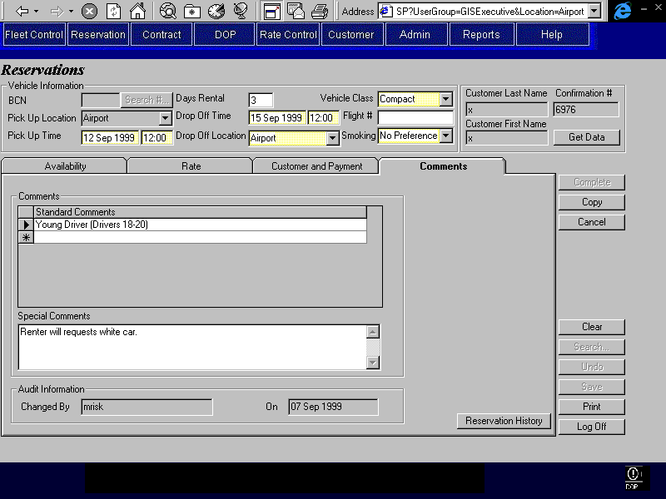
Purpose
The Comments tab allows for the selection and entry of comments about the reservation by the reservation agent. This will facilitate communication between different agents who may work on the same reservation or the resulting contract. The comments are not displayed on the printed contract.
Audit information is displayed at the bottom of the tab. This shows who made the last change to the reservation and when the change was made.
Navigation
Reservation History: Opens the Reservation History sub-screen.
Functions
N/A
Controls
Field | Source | Req* | Validation | Comments
Standard Comments | Reservation Comment, Standard Reservation Comment ID | N | Values controlled by Standard Reservation Comments table.
Special Comments | Reservation, Special Comments | N | Free form text
Last Changed By | Reservation, Last Changed By | D
Last Changed On | Reservation, Last Changed On | D
Technical Notes

Rate Selection
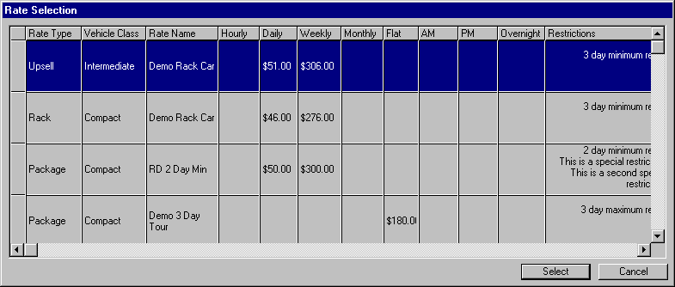
Purpose
The Rate Selection screen displays the applicable rates for a reservation so that an agent may select an appropriate rate to use.
This screen is visible when the View Rates button is pressed on the Rate tab in the Reservation Entry/Update Screen. The rates displayed are determined by information entered in the reservation screen (pick up location, pick up time, days rental, drop off location, vehicle class, and BCD number) and by selections made in the Location Maintenance screen.
The displayed rates can be categorized by rate type. Rate types include the following and are displayed in the order shown:
- Organization rate: the rate associated with the organization or referral specified in the reservation. Rate from BCN Organization will be labelled with BCN in the Type. Rate from Referral Organization will be labelled with Referal BCN in the Type.
- Rack rate: the rate specified as a rack rate in the Location Maintenance Screen - Reservations Rate Tab.
- Upsell rate: the rack rate assigned to the specified location for one vehicle class up from the specified vehicle class in the reservation. The upsell vehicle class is determined in the vehicle class table.
- Package rate: the package rate specified in the Location Maintenance Screen - Reservations Rate Tab. This rate is only displayed if the package length matches or is one day longer than the rental length. This is determined by the maximum day restriction associated with the package rate.
- Promotion rate: the rate specified as a promotion rate in the Location Maintenance Screen - Reservations Rate Tab. This rate is displayed regardless of the vehicle class specified in the reservation. The promotion rates are assigned to the vehicle class for which the promotion is for, in the Location Maintenance screen. For example, to promote a Luxury Car, a promotion rate would be assigned to the Luxury Car. This rate would appear in the rate selection screen regardless of the vehicle class selected in the reservation.
Upon viewing the rates the reservation agent will select the desired rate and press the Select button. The rate information will then be displayed in the reservation screen. If the vehicle class in the selected rate, is different from the vehicle class selected in the reservation, then the vehicle class in the reservation will be updated to that in the rate.
Navigation
Select: Returns to the Reservation Entry/Update Screen and populates the rate information with the selected rate.
Functions
Controls
Field | Source | Req* | Validation | Comments
Rate Type | Location Vehicle Rate Level, Rate Selection Type | D |  | For selected Pick Up Location and Vehicle Class.
Vehicle Class | Location Vehicle Rate Level, Vehicle Class Code | D |  | Display Vehicle Class name.  For selected Pick Up Location and Vehicle Class and Rate Type.
Rate Name | Vehicle Rate, Rate Name | D |  | For Vehicle Rate displayed, for Rate ID in selected record of Location Vehicle Rate Level.
Hourly | Rate Charge Amount, Amount | D |  | For Rate ID and Level in Location Vehicle Rate Level, Type = Regular and Time Period = Hour, and selected Vehicle Class. If more than one, show Rate Charge Amount, Amount with lowest value of Rate Time Period, Time Period Start.
Daily | Rate Charge Amount, Amount | D |  | For Rate ID and Level in Location Vehicle Rate Level, Type = Regular and Time Period = Day, and selected Vehicle Class. If more than one, show Rate Charge Amount, Amount with lowest value of Rate Time Period, Time Period Start.
Weekly | Rate Charge Amount, Amount | D |  | For Rate ID and Level in Location Vehicle Rate Level, Type = Regular and Time Period = Week, and selected Vehicle Class. If more than one, show Rate Charge Amount, Amount with lowest value of Rate Time Period, Time Period Start.
Monthly | Rate Charge Amount, Amount | D |  | For Rate ID and Level in Location Vehicle Rate Level, Type = Regular and Time Period = Month, and selected Vehicle Class. If more than one, show Rate Charge Amount, Amount with lowest value of Rate Time Period, Time Period Start.
Flat | Rate Charge Amount, Amount | D |  | For Rate ID and Level in Location Vehicle Rate Level, Type = Regular and Time Period = Flat, and selected Vehicle Class.
AM | Rate Charge Amount, Amount | D |  | For Rate ID and Level in Location Vehicle Rate Level, Type = Regular and Time Period = AM, and selected Vehicle Class.
PM | Rate Charge Amount, Amount | D |  | For Rate ID and Level in Location Vehicle Rate Level, Type = Regular and Time Period = PM, and selected Vehicle Class.
Overnight | Rate Charge Amount, Amount | D |  | For Rate ID and Level in Location Vehicle Rate Level, Type = Regular and Time Period = OV, and selected Vehicle Class.
Restrictions | Rate Restrictions, Restriction ID; Vehicle Rate, Special Restrictions | D |  | Display all restrictions in list for Vehicle Rate.
Inclusions | Included Optional Extras, Optional Extra ID;  Included Sales Accessories, Sales Accessories ID;  Vehicle Rate, GST Included, PST Included, PVRT Included, Location Fee Included | D |  | Concatenate source and display in list for Vehicle Rate.
Technical Notes
Displaying Inclusions:
When the item being displayed is a flag, display the flag name if the value is Yes and nothing if the value is No.
Displaying Restrictions:
For restrictions that use the parameters Number of Hours or Number of Days, concatenate by displaying the parameter first and then the restriction text.
For restrictions that use the parameter Time of Day, concatenate by displaying the restriction test first and then the parameter.
Selecting Rates to Display:
The rates displayed are determined by entries in the Reservations or Contract screen as well as by the rates selected in the Location Maintenance screen. The entries in the Reservation or Contract screen are used to select which rates to display from the rates selected in the Location Maintenance screen (Location Vehicle Rate Level table) and the Organization Rate table.
The following fields are used from the reservation or contract screen. How to select the rates is outlined below:
- Pick up location
- Pick up time
- Days rental
- Drop off location
- Drop off time
- Vehicle class
- BCD organization information (if entered)
- Referral organization information (if entered)

Selecting rates using the Rates Specified in the Location Maintenance Screen (this is always used):
- Pick up location and vehicle class will identify the Location Vehicle Class record to use. From this a set of Location Vehicle Rate Level records may be identified. Only the records where Location Vehicle Rate Type is the appropriate value should be selected. The three types are walk in, same day reservation, and future reservation (see comment below – Location Vehicle Rate Type).
- The Location Vehicle Rate Level record set is filtered using the pick up time. The pick up time must be inside the Location Vehicle Rate Level Valid To and From values.
- The Rate Availability should be checked to ensure each rate is available for the specified pick up date. If the rate is not available exclude it from the set.
- Exclude any records that violate any of the following restrictions placed on the rate:
  - If there is a restriction: “Saturday night stayover required” and the rental period does not include a Saturday night.
  - If there is a restriction “hour advance reservation required” and the difference in hours between the current time and the pick up time is less than the number of hours associated with the restriction
  - If there is a restriction “day minimum rental” and Days Rental is less than the number of days associated with the restriction
  - If there is a restriction “day maximum rental” and Days Rental is greater than the number of days associated with the restriction or Days Rental is more than one day less than the number of days associated with the restriction
  - If there is a restriction :”Cannot be picked up before” and the pick up time (hours and minutes) is less than the time associated with the restriction
  - If there is a restriction :”Must be returned by” and the drop off time (hours and minutes) is greater than the time associated with the restriction
- Finally the remaining set should be filtered using the drop off location. The following tables should be checked:
- Rate Location Set, Allow All Valid Drop Off Locations for the specified rate, pick up date and pick up location. If this is true then accept the rate. If the value is false then check the Rate Drop Off Location table.
- Rate Drop Off Location, for the specified rate.pick up date and pick up location. If the drop off location is specified then accept the rate, otherwise exclude the rate.
Selecting rates assigned to an Organization (this is only used if a BCD or Referral Organization information is supplied)
- Use the BCD# and the pick up date to find the applicable Organization Rate records and thereby the associated Rates and Levels.
- Ensure that the rates are valid for the specified vehicle class (Rate Vehicle Class table).
- Follow steps 3, 4 and 5 above.
Location Vehicle Rate Type:
When selecting rates, the Location Vehicle Rate Type should be the following values in the situation outlined:
- Walk Up – When the Open Contract Screen is being used to select a rate
- Same Day Reservation – When the Reservation Screen is being used and the Pick Up Date is equal to today.
- Future Reservation – When the Reservation Screen is being used and the Pick Up Date is greater than today.

Reservation Search
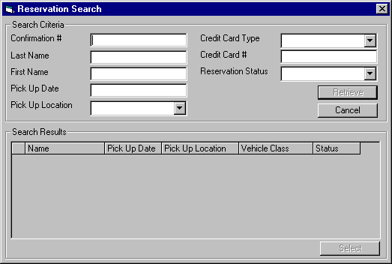
Purpose
This screen allows the agent to search for reservations so that the reservation may be updated or reinstated.
The upper portion of the screen contains the available search parameters. Upon completing the search, a resulting list is displayed on the lower portion of the screen. The user may select one reservation from this list and then double click on the record or press select to update, cancel or reinstate the reservation. To update or reinstate the selected record, the reservation entry/update screen is invoked with the selected reservation information displayed.
Cancellation of a reservation is available only in the reservation details screen because of the complexity involved in refunding or forfeiting deposits.
Navigation
Select: Invokes the Reservation Entry/Update Screen with the information of the selected reservation displayed.
Reinstate Dialogue: Invokes the Reservation Entry/Update Screen with the information of the selected reservation displayed. The reinstate will not take effect until the user hits Save on the Reservation screen. This appears as a dialogue box that appears when the user selects a cancelled reservation. It confirms with the user whether they intended to reinstate or only view the cancelled reservation.
Functions
Retrieve: Searches for reservations based on the search parameters entered. Display the resulting set of rates in the list on the lower portion of the screen.
Cancel: Returns the user to the Reservation Entry/Update screen without selecting a record.
Controls
Field | Source | Req* | Validation | Comments
Search Parameters
Confirmation # | Reservation, Confirmation Number or Foreign Confirmation Number | N
Last Name | Reservation, Last Name | N
First Name | Reservation, First Name | N
Pick Up Date | Reservation, Pick Up On | N
Pick Up Location | Reservation, Pick Up Location ID | N
Credit Card Type | Reservation, Credit Card Type ID;  Reservation Deposit Payment, Credit Card Key | N
Credit Card # | Reservaiton Deposit Payment, Credit Card Key | N
Reservation Status | Reservation, Status | N | Controlled by Status table. | Cannot search on Reservation Status only.
Search Results
Name | Reservation, Last Name, First Name | D |  | Concatenate last and first name.
Pick Up Date | Reservation, Pick Up On | D
Pick Up Location | Reservation, Pick Up Location ID | D
Vehicle Class | Reservation, Vehicle Class Code | D
Status | Reservation, Status | D
Technical Notes
Selection list may be displayed in order by any of the columns.

Deposit/Refund Record
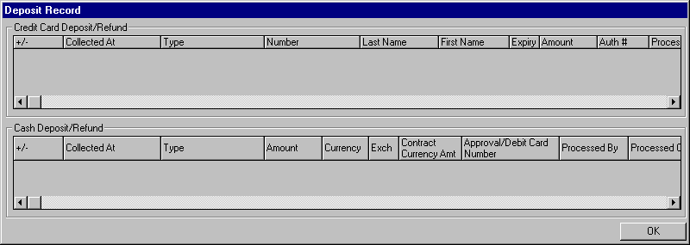
Purpose
This screen allows the agent to view all credit card and cash deposits, refunds, and forfeits that have occurred on the current reservation. The Deposit/Refund Record screen is invoked from the Customer and Payment tab on the Reservation screen.
The upper portion of the screen contains the Credit Card Deposit/Refund grid, which displays all the credit card deposits and refunds that have occurred on the current reservation. The first column displays whether or not the transaction was a deposit or a refund. If the transaction was a deposit that has since been forfeited then the first column will show forfeited. Note that no new transaction is created for a forfeited deposit.
The lower portion of the screen contains the Cash Deposit/Refund grid, which displays all the cash deposits and refunds that have occurred on the current reservation. Like the credit card deposit/refund grid the first column displays whether the transaction was a deposit, refund, or forfeited deposit.
Navigation
N/A
Functions
N/A
Controls
Field | Source | Req* | Validation | Comments
Credit Card Deposit/Refund
+/- | Reservation Deposit Payment, Amount and Forfeited | D |  | Deposit, Refund, or Forfeit  If Reservation Deposit Payment, Amount is negative then value is Refund. Otherwise if Forfeit flag is on then value is forfeit. Otherwise the value is Deposit.
Collected At | Reservation Deposit Payment, Collected At Location ID | D
Type | Credit Card Deposit Payment, Credit Card Key | D
Number | Credit Card Deposit Payment, Credit Card Key | D
Last Name | Credit Card Deposit Payment, Credit Card Key | D
First Name | Credit Card Deposit Payment, Credit Card Key | D
Expiry | Credit Card Deposit Payment, Credit Card Key | D
Amount | Reservation Deposit Payment, Amount | D
Auth # | Credit Card Deposit Payment, Authorization Number | D
Processed By | Reservation Deposit Payment, Collected By | D
Processed On | Reservation Deposit Payment, Collected On | D
Cash Deposit/Refund
+/- | Reservation Deposit Payment, Amount and Forfeited | D |  | Deposit, Refund, or Forfeit  If Reservation Dep Payment, Amount is negative then value is Refund. Otherwise if Forfeit flag is on then value is forfeit. Otherwise the value is Deposit.
Collected At | Reservation Deposit Payment, Collected At Location ID | D
Type | Cash Deposit Payment, Cash Payment Type | D
Amount | Cash Deposit Payment, Foreign Currency Amt Collected | D
Currency | Cash Deposit Payment, Currency ID | D
Exch | Cash Deposit Payment, Exchange Rate | D
Contract Currency Amt | Reservation Deposit Payment, Amount | D
Approval/Debit Card Number | Cash Deposit Payment, Identification Number | D
Processed By | Reservation Deposit Payment, Collected By | D
Processed On | Reservation Deposit Payment, Collected On | D

Technical Notes
+/- Column:
If the deposit amount is negative then the value will always be ‘Refund’.
If the deposit amount is positive then
If the forfeit flag is on then the value will be ‘Forfeited’
If the forfeit flag is not on then the value will be ‘Deposit’

Reservation History
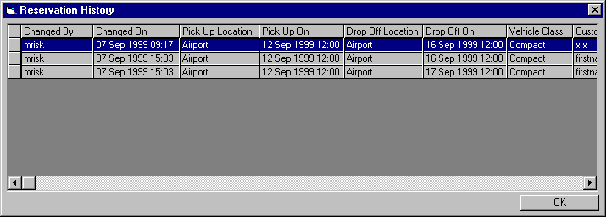
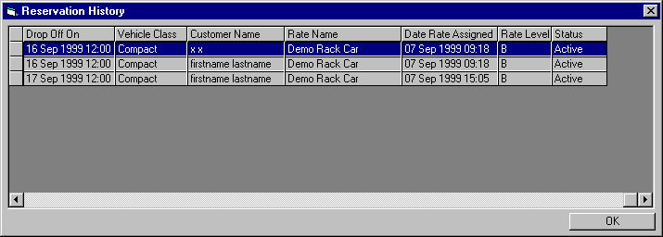
Purpose
The Reservation History screen allows the user to view all changes that have happened to the reservation with respect to the fields displayed in this screen. Who made the change and when the change was made are also displayed. Each save of a reservation that results in a change to one or more of the displayed fields will result in a new record in the reservation history. Changes to the reservation that do not affect the displayed fields will not produce a reservation history record.
The Reservation History screen is invoked from the Reservation History button on the Comments tab in the Reservation Entry and Update screen.
Navigation
N/A
Functions
N/A
Controls
Field | Source | Req* | Validation | Comments
Changed By | Reservation Change History, Changed By | D
Changed On | Reservation Change History, Changed On | D | Date/Time
Pick Up Location | Reservation Change History, Pick Up Location ID | D |  | Display pick up location name.
Pick Up On | Reservation Change History, Pick Up On | D | Date/Time
Drop Off Location | Reservation Change History, Drop Off Location ID | D |  | Display drop off location name.
Drop Off On | Reservation Change History, Drop Off On | D | Date/Time
Vehicle Class | Reservation Change History, Vehicle Class Code | D |  | Display vehicle class name.
Customer Name | Reservation Change History, First Name and Last Name | D |  | Concatenate first name and last name.
Rate Name | Reservation Change History, Rate ID | D |  | Display vehicle rate name.
Date Rate Assigned | Reservation Change History, Date Rate Assigned | D | Date/Time
Rate Level | Reservation Change History, Rate Level | D
Status | Reservation Change History, Status | D |  | Display status description.
Technical Notes

Truck Inventory Maintenance
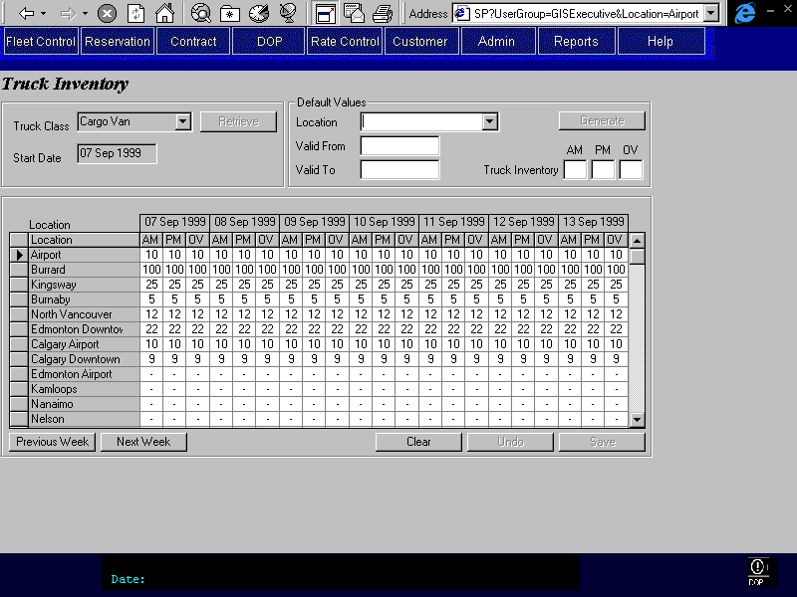
Purpose
This screen provides a means to maintain the truck inventory by vehicle class and by location.
The information displayed is for the selected truck class. Default inventory values may be entered for a range of dates for each time period. Individual inventory values may be updated or entered for each location and day.
Navigation
N/A
Functions
Previous Week: Display the seven days preceding the seven days currently displayed.
Next Week: Display the seven days following the seven days currently displayed.
Generate: Populate the Selected Location with the default values entered in the Default Value section.
Controls
Field | Source | Req* | Validation | Comments
Truck Class | Truck Inventory, Vehicle Class Code | Y | Value controlled by Vehicle Class Table | Display Vehicle Class Name
Start Date |  | Y | Date | Default to current date. Used to determine what date to start data display at.
Default Values
Location | Truck Inventory, Location ID | N | Value controlled by Location Vehicle Class table for selected Vehicle Class. | Location name is displayed.
Valid From |  | S | Date | Required if Location is entered.  The valid from/to dates specify which days should be defaulted.
Valid To |  | S | Date  Cannot be more than two years in the future. | Required if Location is entered.
Truck Inventory – AM | Truck Inventory, AM Inventory | S | Numeric | Required if Location is entered.
Truck Inventory - PM | Truck Inventory, PM Inventory | S | Numeric | Required if Location is entered.
Truck Inventory - OV | Truck Inventory, OV Inventory | S | Numeric | Required if Location is entered.
Matrix
Location | Location Vehicle Class, Location ID | D |  | Location name is displayed.
Day Date | Truck Inventory, Date | D
AM | Truck Inventory, AM Inventory | Y | Numeric | For specified location, vehicle class, and date.
PM | Truck Inventory, PM Inventory | Y | Numeric | For specified location, vehicle class, and date.
OV | Truck Inventory, OV Inventory | Y | Numeric | For specified location, vehicle class, and date.
Technical Notes
Valid From / Valid To:
The inventory records are kept by day. When the Valid To and From dates are entered for a location, this will populate all records that fall within the entered dates.
- Backdating is not allowed
- Overlaps are allowed since each day is stored as a separate record
- Contiguity is not required
Truck Availability:
When the inventory is increased or reduced, the same change should be applied to the availability for that date and time period. That is, upon Save, update the Truck Availability for the location, date, and vehicle class to reflect any changes in inventory. For example: the 1 Ton truck inventory is increased from 5 to 8 for Nov 15 to 20 at the Burnaby location. The availability for 1 Ton trucks from Nov 15 to 20 at Burnaby should be increased by 3.
Definition of Time Blocks:
AM: 07:00 to 12:00
Rentals that begin (check out) on or between 07:00 and 12:29 will be considered affecting the AM time block availability. Rentals that end (check in time) on or between 07:01 and 12:30 will be considered as affecting the AM time block availability. Rentals that extend through the entire AM time block are considered as affecting the AM time block availability.
PM: 12:30 to 17:30
Rentals that begin (check out) on or between 12:30 and 17:29 will be considered affecting the PM time block availability. Rentals that end (check in time) on or between 12:31 and 17:30 will be considered as affecting the PM time block availability. Rentals that extend through the entire PM time block are considered as affecting the PM time block availability.
OV: 17:30 to 06:59
Rentals that begin (check out) on or between 17:30 and 06:59 will be considered affecting the OV time block availability. Rentals that end (check in time) on or between 17:31 and 07:00 will be considered as affecting the OV time block availability. Rentals that extend through the entire OV time block are considered as affecting the OV time block availability.
Order of Locations Displayed:
The locations displayed and their order will be as follows:
- Show only rental locations that carry the selected vehicle class.
- Show current location first.
- Show all locations with the same owning company as the current location. Display these by hub starting with the hub of the current location. Display alphabetically within a hub.
- Display any remaining locations. These locations should also be grouped by hub and alphabetically within a hub.

Reports
Reports to be designed by Budget personnel at a future date.

“No Show” Reservations by Date Range
Will be split into two categories, depending on whether a deposit was charged or not.

Number of Reservations
By date and time of day, vehicle class and rate code.

Potential No Shows
A periodic (perhaps weekly) list of reservations with pick up dates in the near future where the customer has a number of previous no shows. Will be used to contact the customer by telephone to confirm if they still want the reservation.

Upcoming Direct Bill Reservations with Insufficient Credit
Upcoming reservations with a payment method of direct billing where the expected pre-authorization amount exceeds the company’s available credit.

Background Processes

Bill for Maestro No Show Reservations
Do not use this definition of Bill for Maestro No Show Reservations. This process is replaced by Process No Show Reservations, still a batch process, defined in the Maestro Interface Business Design document.

Functions

Accounting Interface Entries for Reservations
This section describes the accounting entries to be generated for each type of contract transaction.
For each Reservation transaction completed (i.e. when user presses Save button, or Print button when no prior save), a Business Transaction will be written to the GIS database along with a number of G/L and/or A/R Transactions containing the accounting information (when the transaction involves a deposit payment, refund or forfeit). This accounting information is posted to the G/L and A/R on a nightly basis following close of the business day.
G/L and A/R Transactions will be generated from the Reservation screen for each of the following.
- Credit Card Deposits
- Credit Card Refunds
- Cash Deposits
- Cash Refunds
- Deposit Forfeits
Note that in practice deposits will only be collected, refunded and forfeited for Reservations that have a Budget BC Pick Up Location.
The amount in either transaction is output as positive if it is a debit, negative if it is a credit.
The Business Transaction for the Reservation Entry/Update will have:
- RBR Date = current RBR date
- Transaction Date = current date
- Transaction Type = “RES”
- Transaction Description = Deposit, Refund, Cancellation (if forfeit by cancellation), No Show (if processed by no show batch)
- Contract Number = null
- Confirmation Number = current Confirmation number
- Sales Contract Number = null
- Location ID = ID of location where Reservation deposit/refund was collected/issued
- User ID = User ID of user who entered Reservation deposit/refund
- Entered On Handheld = no
- Signature Required = no
In the following specifications, unless otherwise specified, all A/R Transactions will have:
- Must Be Invoice = no
- Purchase Order Number = null
- Loss Of Use Claim Number = null
- Adjuster First Name = null
- Adjuster Last Name = null
- Credit Card Key = null
- Authorization Number = null
- Total Contract Amount = null
- Total Contract Taxes = null
- Budget Claim Number = null
- Ticket Number = null
- Issuing Jurisdiction = null
- Credit Card Deposits
Inputs:
- Credit Card Type
- Credit Card Number
- Credit Card First Name
- Credit Card Last Name
- Credit Card Expiry Date
- Deposit Amount

Create accounting transactions for each credit card deposit as follows:

Post | When | Field Values
To |  | DB/CR | Amount | Account (Source) | Other
G/L | Always | Credit | Deposit Amount | G/L Deposit Account  (System Values)
G/L | Always | Debit | Deposit Amount | G/L Receivables Clearing Account  (System Values)
A/R | Always | Debit | Deposit Amount | A/R Payment Account  (Credit Card Type) | See Note 1 below
Note 1: For other credit cards (i.e. not major credit cards – ones not electronically authorized) and for lease cards:
- Set the Credit Card Key to the key of the credit card used for the deposit being posted and Authorization Number to the authorization number entered for the deposit.
- Set Total Contract Amount to null.
- Set Total Contract Taxes to null.
- Credit Card Refunds
Generate the same entries as for a Credit Card Deposit with Debits and Credits reversed.
- Cash Deposits
Inputs:
- Cash Payment Method
- Foreign Currency Deposit Amount
- Currency
- Deposit Amount

Create accounting transactions for each cash deposit (only Cdn$ allowed) as follows:

Post | When | Field Values
To |  | DB/CR | Amount | Account (Source) | Other
G/L | Always | Credit | Deposit Amount | G/L Deposit Account  (System Values)
G/L | Always | Debit | Foreign CurrencyDeposit Amount | G/L Receivables Clearing Account  (System Values)
A/R | Cash Payment Method = ‘Debit Card’ | Debit | Foreign Currency Deposit Amount | A/R Debit Card Account  (System Values)
A/R | Cash Payment Method not = ‘Debit Card’ | Debit | Foreign Currency Deposit Amount | A/R Canadian Cash Account  (System Values)

Cash Refunds
Cash refunds are actually recorded as cash deposits with a Cash Payment Method of Direct Refund or Mail Refund. All cash refunds are in Cdn currency.
Inputs:
- Cash Payment Method (Direct Refund or Mail Refund)
- Deposit Amount

Create accounting transactions for each cash refund as follows:

Post | When | Field Values
To |  | DB/CR | Amount | Account (Source) | Other
G/L | Always | Debit | Deposit Amount | G/L Deposit Account  (System Values)
G/L | Cash Payment Method not = ‘Mail Refund’ | Credit | Deposit Amount | G/L Receivables Clearing Account  (System Values)
G/L | Cash Payment Method = ‘Mail Refund’ | Credit | Deposit Amount | G/L Cash Refund Payables Clearing Account  (System Values)
A/R | Cash Payment Method not = ‘Mail Refund’ | Credit | Deposit Amount | A/R Canadian Cash Account  (System Values)

- Deposit Forfeits
Inputs:
- Deposit Amount
- Vehicle Type

Create accounting transactions for each forfeit as follows:

Post | When | Field Values
To |  | DB/CR | Amount | Account (Source) | Other
G/L | Always | Debit | Deposit Amount | G/L Deposit Account  (System Values)
G/L | Always | Credit | Deposit Amount | G/L Revenue Account  (Charge G/L) | For Vehicle Type and Charge Type =‘Other’

Test Scenario List
- New reservation over phone:
  - No BCN
  - Same pick up and drop off location
  - Requires a baby seat
  - BCAA member

- New reservation over phone:
  - No BCN
  - Different pick up and drop off locations
  - No organization affiliation
  - Choose other rate than rate that is originally shown in the base rate tab
  - Apply flex discount
  - Phoned after seeing an advertisement about Budget in a magazine

- New reservation over phone:
  - No BCN
  - Same pick up and drop off location
  - Vehicle not available at pick up location
  - Change pick up location

- New reservation over phone:
  - No BCN
  - Same pick up and drop off location
  - Vehicle not available at pick up location
  - Change vehicle class

- New reservation over phone:
  - No BCN
  - Same pick up and drop off location
  - Works for a Corporation and can provide a corporation number.

- New reservation over phone:
  - No BCN
  - Different pick up and drop off locations
  - Works for a Corporation and does not remember the corporation number.

- New reservation over phone:
  - Provides BCN
  - Same pick up and drop off location

- New reservation over phone:
  - Provides BCN
  - Same pick up and drop off location
  - Requires a baby seat and a ski rack

- New reservation over phone:
  - Leisure customer to inquire about rate
  - Requests a CC vehicle to be picked up at the Downtown location
  - Vehicle not available Downtown, substitute location
  - Customer hesitant over rate, substitute with another rate
  - Complete reservation

- New reservation over phone:
  - Leisure customer to inquire about rate
  - Requests a Compact vehicle to be picked up at the Downtown location
  - Vehicle not available Downtown, substitute vehicle class
  - Customer hesitant over rate, apply flex rate
  - Do not complete reservation

- New reservation over phone:
  - Customer wishes to book a one ton truck for 5 hrs at month end
  - Deposit is required to confirm the reservation
  - Deposit is waived
  - Requires a dolly, 5 blankets, 5 boxes, and a baby seat

- New reservation over phone:
  - Hotel concierge (Allison from Four Seasons Hotel) makes a reservation for a customer to pick up a vehicle from the Downtown location
  - Customer is a leisure customer
  - Customer will take a taxi to the Downtown location and will be reimbursed for $7.00

- New reservation over phone:
  - Hotel concierge (Allison from Four Seasons Hotel) makes a reservation for a customer to pick up a vehicle from the Downtown location
  - Customer is a Budget corporate customer
  - Customer will take a taxi to the Downtown location and will be reimbursed for $7.00

- New reservation over phone:
  - Customer wishes to book a Full Size vehicle to be picked up at the Downtown location
  - BCAA member and inquires about the discount
  - Inquires about coverage for the vehicle
  - Requests a red Sable if possible

- New reservation over phone:
  - Customer wishes to book a Sport convertible at the Kingsway location
  - Deposit required
  - Customer is a Budget corporate customer and entitled for a corporate discount

- New reservation over phone:
  - Travel agency is booking a vehicle for their client
  - IATA number given over phone
  - Client requests the cheapest rate available
  - Inquires if any package or special rates

- New reservation over phone:
  - Customer wishes to book an Economy vehicle
  - Agent upsells the customer to a Compact vehicle

- New reservation over phone:
  - Customer requests a reservation using an advertised promotional rate
  - Customer saw advertisement in the Vancouver Sun.

- New reservation over phone:
  - Customer wishes to book a 1 Ton truck
  - Rental to be paid by direct billing
  - No deposit required

- New reservation over phone:
  - Customer wishes to book a one way truck
  - Requires drop off in another city
  - Deposit required ($200)

- New reservation over phone:
  - Customer wishes to book a vehicle for pick up from a Non-BRAC BC Ltd. Location

- New reservation over phone:
  - Customer requests a faxed confirmation

- Update existing reservation over phone:
  - Change pick up date

- Update existing reservation over phone:
  - Change vehicle class

- Update existing reservation over phone:
  - Change rental length

- Update existing reservation:
  - Change vehicle class
  - Add LDW level 1

- Cancel existing reservation over phone:

- Inquiry over phone:
  - Inquire about rental location address and hours

- New reservation at a location:
  - Deposit is required

Controls & Audit Trail
The following data will be saved each time a reservation is changed: pick up date and time, pick up location, drop off date and time, drop off location, vehicle class, selected rate, customer name, user ID that made the change, and date the changed was made.

Security Requirements
This section is superseded by the GIS Security Business Design.
Object | Type | Manager | Supervisor | Agent
Reservation Entry and Update | Screen | Y | Y | Y
Availability | Tab | Y | Y | Y
If no availability, override and allow reservation | Function | Y | Y | N
If cancellation less than minimum notice, override and allow deposit refund | Function | Y | Y | N

Business Transaction Volumes
Transaction | Average | Peak
Total calls (including reservation and contract inquiries) | 1419/day | 200/hour  2054/day  63668/month (August)
Extensions | 22/day | 5/hour
Reservation bookings | 281/day | 60/hour

Tables without Maintenance Screens
This section is superseded by the Production System Maintained Files document.
- Standard Reservation Comments
- Credit Card Type
- Reservation Cancellation Reasons
- Marketing Source
- Member Discount
- Payment Method
- Credit Card
- Cash
- Direct Bill

Lookup Table Entries
This section is superseded by the Production System Maintained Files document.
- ‘no show’ time limit (hours)

Data Model

Revision History

Version 2.00
- Clean up documentation and make consistent with the GIS standards.

